VAPT 2ndReport

1 – Vulnerability scanning
Target: 192.168.0.125
Tools: Nessus
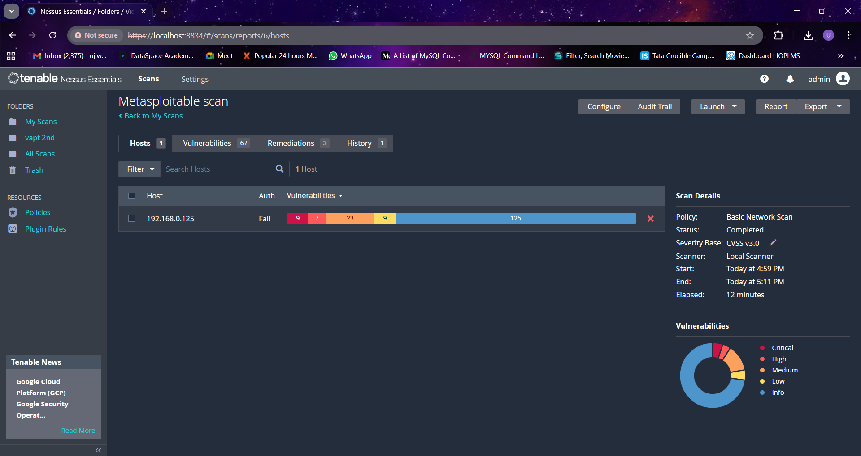
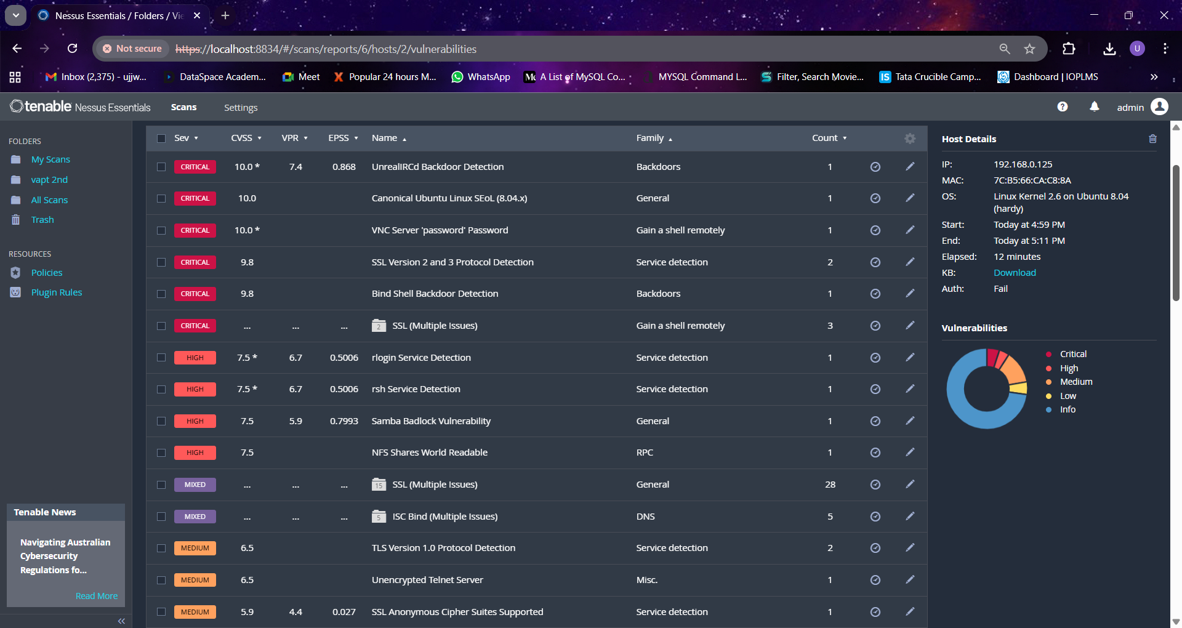
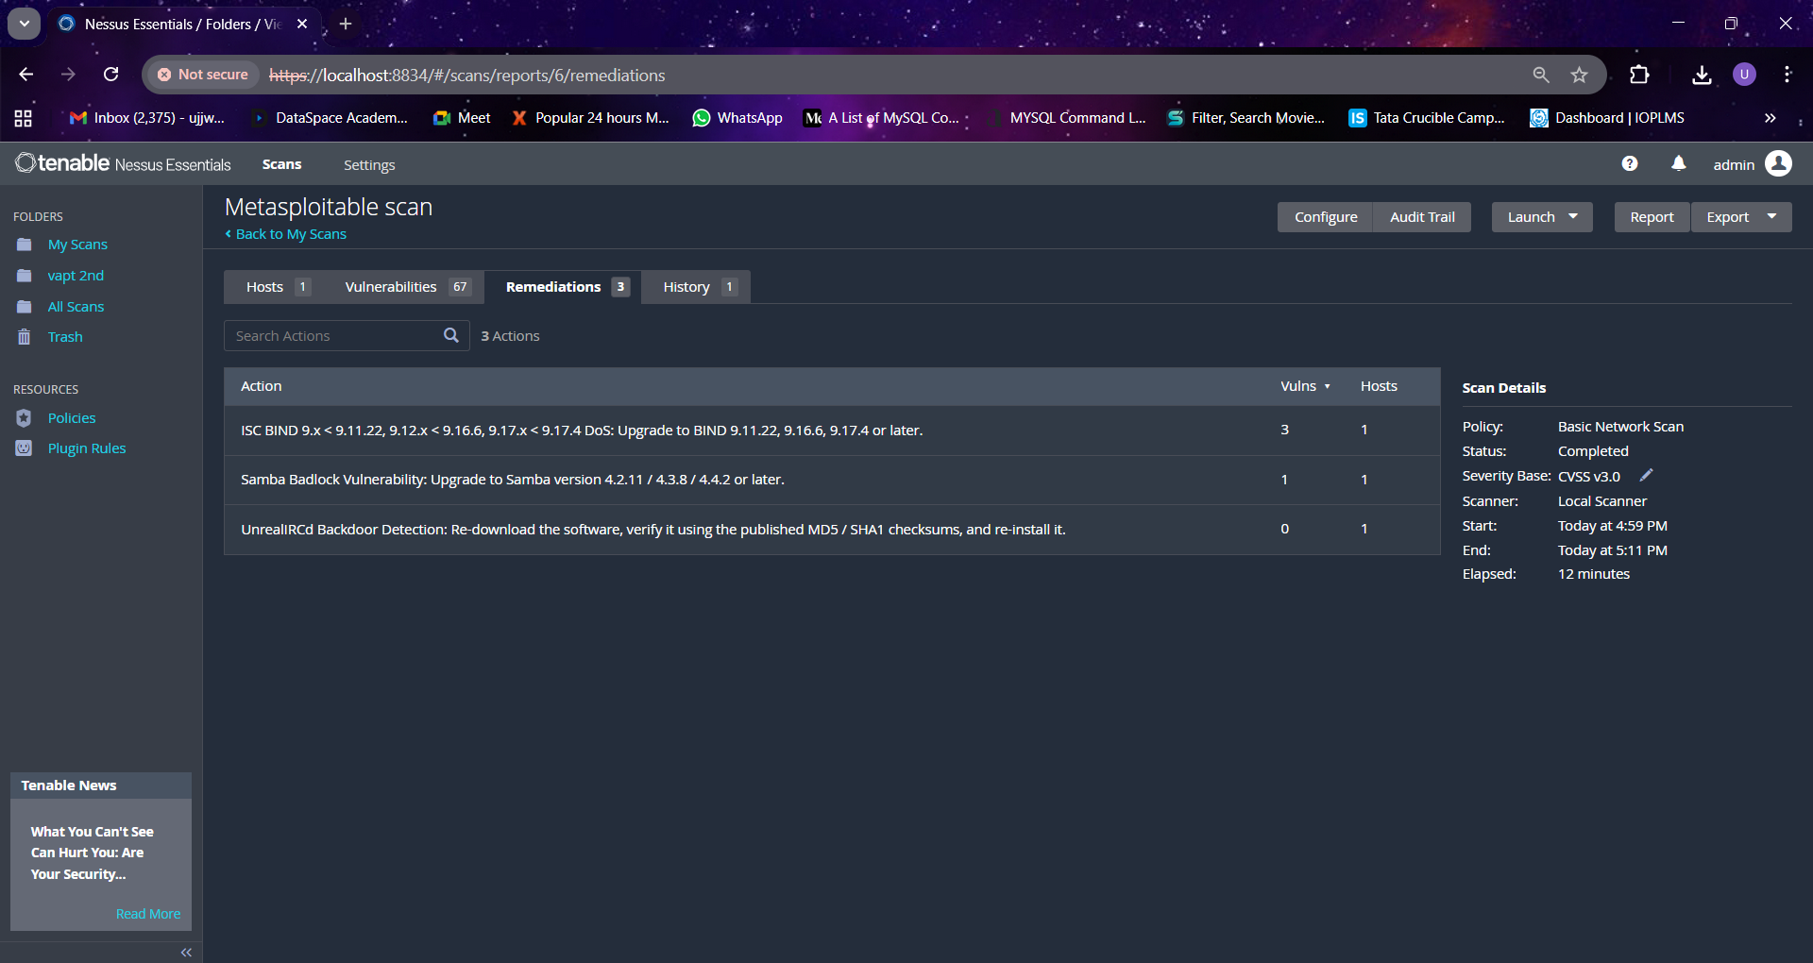
2 – Prioritization and CVSS
Target: 192.168.0.125

Vulnerability | CVSS | Priority
Anonymous FTP | 8.6 | High
Outdated openSSH | 8.3 | High
Telnet | 8.2 | high
Directory browsing | 5.4 | Medium
Tomcat | 9.8 | Critical
Weak Credential | 9 | Critical
Info Disclosure | 7.3 | Medium
Missing anti CSRF Token | 5.4 | Medium
DNS server version disclosure | 3.1 | Low
Bind shell | 9.8 | Critical

3 - Exploitation

Target: 192.168.0.125
